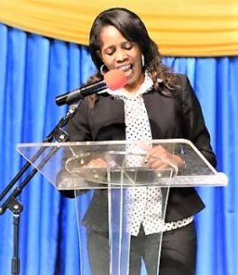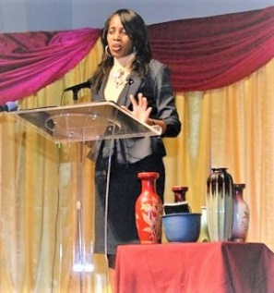
To request for Workshop/Seminar Engagements
Opened Palms Ministry
910-635-3835 or visit
www.openedpalms.com
nicolesmith@openedpalms.com
facebook.com/openedpalms1

Nicole Smith
28-Day Devotionals for SINGLES
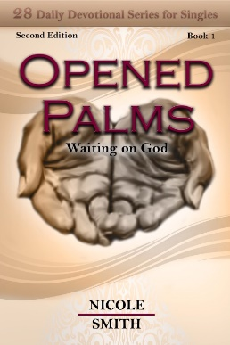
BOOK 1
Opened Palms- “Waiting on God” was birthed from many lessons. It was during this birthing process that I learned how to really clench my fist. Not a clenched fist that represented being mad, but a fist that held on tightly to every-thing as to not lose anything else. A clenched fist was what I became so familiar with. That was the comfort zone I developed. Until….. I realized what that I could really open my hands, not just a little bit, but a completely “Opened Palm.” The courage to trust Him enough to open that fist and let go of everything that I thought I was holding on to but it was actually holding on to me, thus the key to Waiting on God.
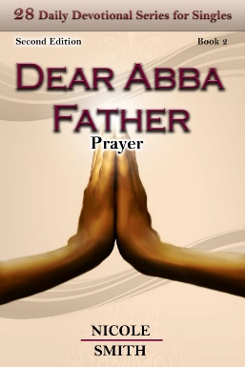
BOOK 3
Passion Fruit- “Our Passions and Desires” As enticing as the passion fruit’s scent is, sexual sin is so enticing and alluring that its power binds and holds you in bondage and makes you a slave to that sexual sin. Our passions and desires is a subject that you don’t hear preached much from the pulpit. It is taught in our Marriage ministries, but has become taboo in our Single’s Ministries.
These 28 days together are designed to teach us how to crucify our flesh with its passions and desires. The key word is Holiness. God has called us all to a life of Holiness. A life set apart for us to become more and more like Him, one day at a time.
BOOK 2
Dear Abba, Father- “Prayer” -In the midst of our trials, God wants to teach us to stay in constant communion with Him. Prayer is a discipline that we all must develop. Just imagine, we have a father who is just waiting to wrap us in His loving arms, hold us, and let us know, “I got you. I have not forgot about you.” There is power when we learn the discipline called “Prayer”
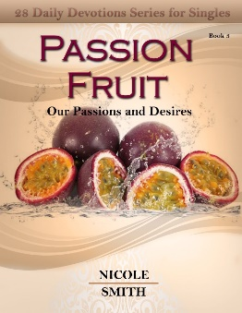
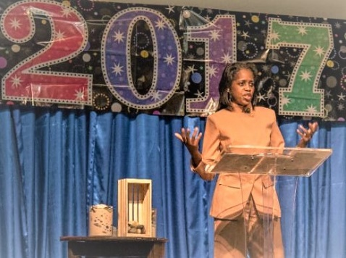
Coming Soon “28-Day Devotionals for Singles”
Book 4- Food For Thoughts- Our Thought Life
Book 5- Living Beneath Our Privilege- Our Standards
Book 6- Friend or Foe?- The Company We Keep
Book 7- Powerful Book of God’s Promises-
Putting Scripture to Memory

